A000-Afr-Gabon-Fang-Reliquary male byéri figure with a central crested helmet-Early 20th c

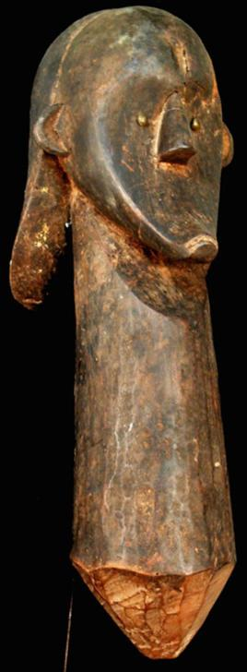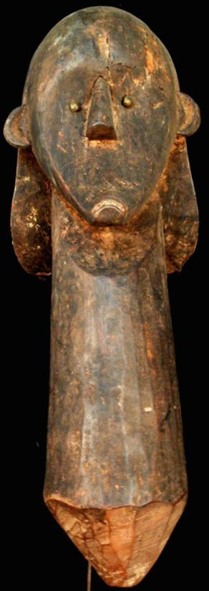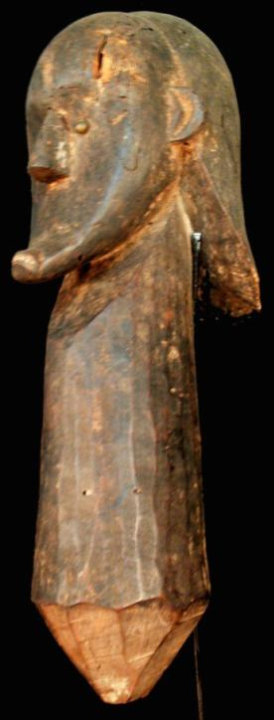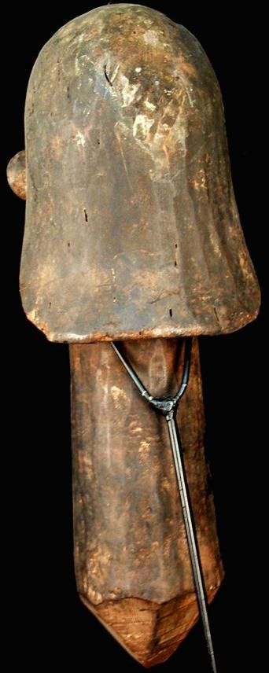

Figs. 1-4. Afr-Gabon-Fang-Reliquary male byéri figure with a central crested helmet-Early 20th c

Case No.: 6

**Accession No.**

**Formal Label:** Afr-Gabon-Fang-Reliquary male byéri figure with a central crested helmet-Early 20th c

**Display Description:**

This Fang reliquary is a male byéri figure with a central crested helmet from northern continental Equatorial Guinea. The head is typical of the Ntumu style with a prominent forehead, hollow face, eyes made from shirt buttons glued with resin (Perrois 1990: 114). Since this is only a bust the function must have been an apotropaic one placed near a reliquary.

**LC Classification:**

**Date or Time Horizon:** Early 20th c

**Geographical Area:** northern continental Equatorial Guinea

**Map:**

**GPS coordinates:**

**Cultural Affiliation: Fang**

**Media: wood, metal**

**Dimensions:** 16.535 inches high

**Weight:** 4.57 pounds

**Condition:**

**Provenance:**

**Discussion:**

**References:**

Perrois, Louis, Delage, Marta Sierra. 1990. *The art of Equatorial Guinea: the Fang tribes*. New York: Rizzoli.

**Appendix:**

